Cinnamon Apples
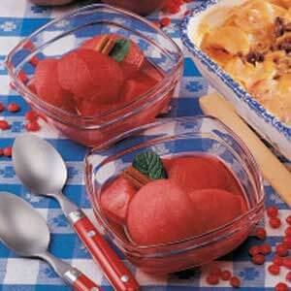
Prep Time 20 min + chilling
6 Servings
Ingredients
2 cups water
1 ½ cup red-hot candies
1/3 cup sugar
6 medium tart apples, peeled and quartered
Directions
- In a large saucepan, bring the water, candies and sugar to a boil over medium heat. Boil and stir until candies and sugar are dissolved.
- Reduce heat. Carefully add apples. Cook, uncovered, until apples are tender. Cool slightly.
- With a slotted spoon, transfer apples to a serving dish. Pour sugar syrup over apples. Cool slightly. Cover and refrigerate for at least 3 hours.

Notes
Leftover syrup can be used for waffles or pancakes for any breakfast…..not just New Year’s Day breakfast!!!!

